**Introduction:**

1. Little is known – especially time correlated mutation and rates.

We need to single cell sequence entire families with high mutation detection at every generation

Users may choose to input the pedigree information and upload the VCF file at the same time, or to upload the VCF file only.

By inputting the family description in PED format into the ‘Pedigree’ text area (Fig. 1a), the pedigree chart of the family can be generated and displayed in the ‘Pedigree’ tab.( If an individual is in the pedigree, his/her basic information described in the input PED text, such as family ID, individual ID, father ID, mother ID, gender, phenotype, etc., are also listed.)

2. Bacterial mutation rate study

In collaboration with Soo Hong and Paul Blainey, in Bacterial mutation rate study. First, we want to assess whether bacterial mutation is consistent across its evolution or does mutation vary. To assess this, we develop simulations of bacterial evolution. Further, we developed probability models to discriminate bacterial evolution patterns from whole genome sequencing SNP data. If interested, please contact: [nikbearbrown@gmail.com](mailto:nikbearbrown@gmail.com)

**Readings:**

1. amino acid & DNA:

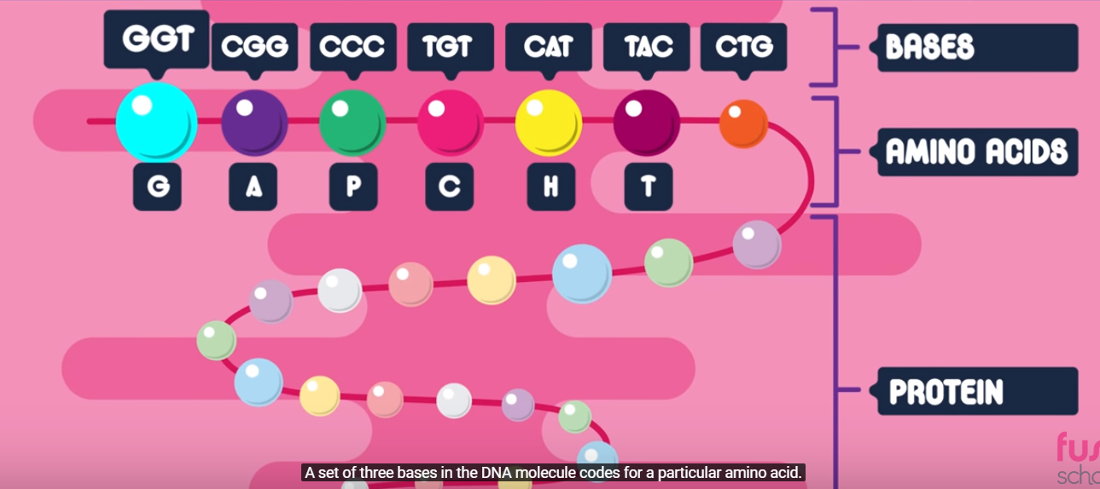

2. DNA, Gene:

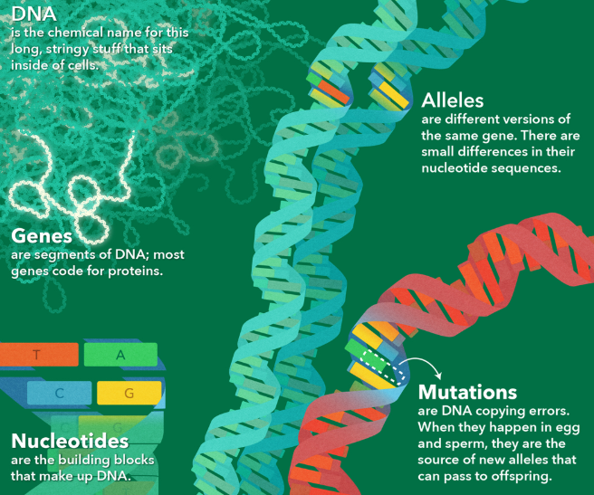

2. Indel:

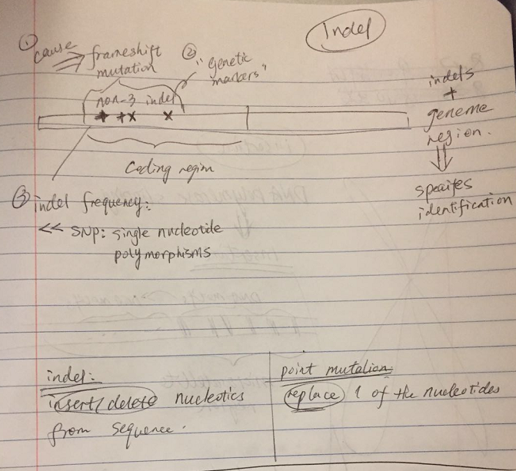

3. Insertion:

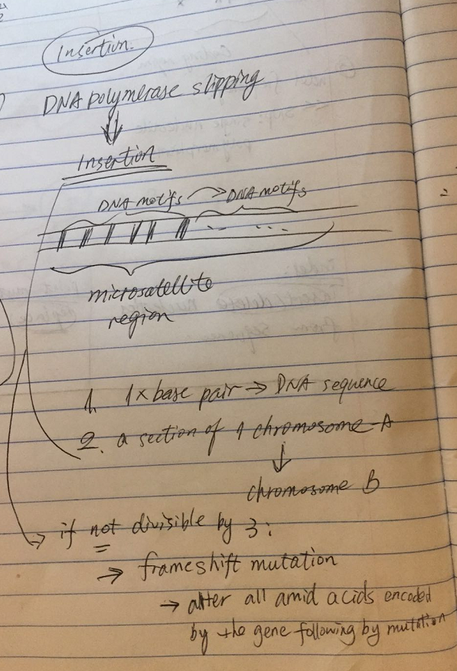

4. Allel:

5. Mutation:

